

**SCSJ3104/SCSV3104**

APPLICATION DEVELOPMENT

(Session 2018/2019 Semester 3)

School of Computing

Universiti Teknologi Malaysia

**PROJECT PROPOSAL**

**PREPARED BY:**

|  |  |  |
| --- | --- | --- |
| **NO.** | **NAME** | **MATRIC NO.** |
| 1. | MOHD FAISAL AMINUDDIN BIN MOHD SALLEH | B17CS3010 |
| 2. | MUHAMMAD AZAM BIN RAFIEE | B17CS3013 |
| 3. | KHAIRUL IDZHAM BIN KAMARUZAMAN | B17CS3006 |
| 4. | WAN NUR KHALISHAH BT MASRY | B17CS3033 |
| 5. | MUHAMMAD AMIN BIN IZAM HASRI | B18CS0012 |

**PREPARED FOR:**

PROF DR. MOHD SHAFRY BIN MOHD RAHIM

Section 01

**TABLE OF CONTENTS**

TABLE OF CONTENTS 2

* 1. Project Overview 3
  2. Problem Statement 3
  3. Objectives 4
  4. System Scope 4
  5. Requirements and Specifications 6
  6. Business Model 7

APPENDICES 8

1. Minutes of The First Meeting 9
2. Minutes of The Second Meeting 14
3. **Introduction**

Today, tuition is more common on primary and secondary school students in Malaysia. According to survey analysis, 90% of parents in Malaysia willing to send their primary and secondary school children to take an extra tuition classes after school that conducted by Malaysia government or private schools. This is because parents hope that their children will able to enhance their academic performance on weaker subject. It is not easy to find the right tutor for their children because traditionally parents have limited information about the availability of tutors within their housing areas.

For this project, the website development will develop to provide a platform for the parents to search for tutors and hire as their children’s tutor and to provide job opportunities for tutors mainly in Malaysia. This offered another alternative solution for parents to select and find suitable tutors for their children. Besides, tutors also can grab more job opportunities to advertise their current and future available classes to public more easily.

1. **Problem Statement**

Firstly, working as a private tutor has its ups and downs. The good things are the payments are always good while the drawbacks of tutoring are it is not easy to search for student. This is because the best way tutor can do to find students are to advertise themselves, create some flyers or posters and put them here, there and everywhere thinking that people would see it but it does not work as expected since there are other services that have the same idea of advertising thus overshadowing these tutors’ advertising flyers. People may not take a second look because all the flyers become cluttered and hard to read.

Besides, searching for tutors is not easy. As for parents who want to find private tutors for their children they will have difficulties because traditionally parents have limited information about the availability of tutors within their housing areas and they will search or get information for tutors through the word of mouth from friends, family members of flyers advertise by the tutor. The problem is that it involves time which the parents will need to discuss with the tutor or some may required physically approach tutors which they probably do not have all the time resulting the tutor schedule being booked by other students.

1. **Objectives**

The main objective of this project is to develop a web application platform for the parents and tutors to hire and interact among each other. This website allows all tutors to register and gather to be easier for parents in searching for tutors.

This project objective listed as follow:

* + - 1. To create job opportunities for tutors by creating their own profile to allow access by parents.
      2. To provide convenience for parents that are having difficulties in reaching and getting tutors for their children through the online tutoring searching within their own housing areas.

1. **System Scope**

In general, this project mainly involved in develop a web application that act as medium to provide matching services between parents and tutors within Malaysia to allow local parents to book tutors more easier and locate suitable tutors for their children. For tutors, this system enables tutors to advertise their services easier and to spread their business.

The project scopes that have been identified for this project are listed below:

1. All functionalities for this system mainly is develop for user, tutors and administrator.
2. The system is focused on the searching the affordable tutorial service that meet the needs and requirements of user and also booking the available time for tutorial service.
3. All users involve in this system will play its own role such as for administrator to manage registered user, advertise tutoring service for tutors, searching the right service that accomplished user criteria for parents and communication services for all students, tutors and parents.

**User/Client**

* User can register, update profile, request or cancel reservation.
* Enable user to search the tutoring service provided.
* User can view tutor profile and give feedback of the tutoring service.
* Enable user to make online payment.
* User able to deactivate or terminate account.

**Tutor**

* Tutor can register, update profile, and decline a user request.
* Enable tutor to approve or reject the booking and update their tutorial price.
* Tutor can view feedback and inquiries.
* Tutor is required to pay the monthly subscription fees.

**Administrator**

* Eliminate and view the tutor details.
* Admin is able to view the statistic the whole system.
* Admin can view the total profit/royalty that systems accomplish.

The vision of this system is providing service that targeted low barrier entry for all parents and tutors by introduce low cost services fees compare to existing similar commercial website. Therefore, this system only will ask for small amount fee to tutor as royalty they success to enrol new student and got their first paid. Above and beyond, this project will aim as the large community gather place for tutor to gather and search for job opportunity available through online.

1. **Requirements and Specifications**

Developing a web application is critical to meet the expectation of all users’ expectation. The proposed system requirements involved are:

* Functional Requirements
* Non-functional Requirements

**5.1 Functional Requirements**

The functional requirements of the proposed project are listed below:

1. The system should be able to register new accounts according to given account types (tutors or student).
2. The system must show lists of available tutors registered along with their ratings, subjects offered and descriptions.
3. The system should be able to send email based on certain conditions (e.g. new account sign up, class booking, message from student to tutor or vice-versa).
4. The system must allow students to view details of selected tutor such as his/her class schedule, the status of those classes, reviews on that tutor, etc.
5. Students should be able to book their desired class slots from selected tutors.
   1. **Non-Functional Requirements**

The functional requirements of the proposed project are listed below:

1. The system should be able to handle up to 10 account registrations at a time.
2. The website should be capable enough to handle 10 thousand users without affecting its performance.
3. Any email sent must not have a transfer latency of more than 2 hours.
4. Any booked class slots should be updated within 5 minutes in real-time.
5. Tutors shall be able to specify their own tuition fees.
6. The web application shall implement using bootstrap that enable shrink the contents according to client’s screen resolution.
7. The web application able to browse using mobile devices and desktop computer
8. **Business Model**

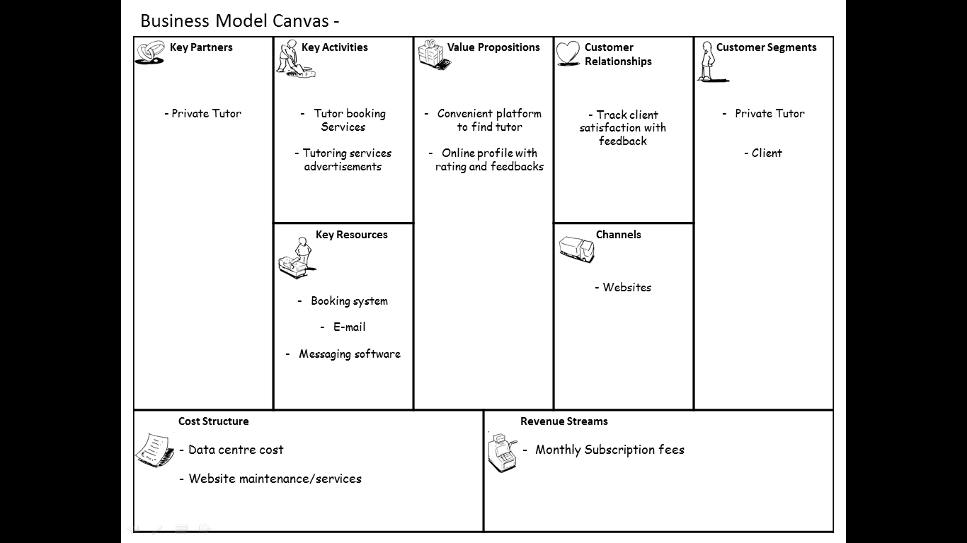The business model of the proposed system is illustrates below:

**Diagram 6.1:** The Business Model of Proposed System

**APPENDICES**

**APPENDIX A:**

Minute of the First Meeting

**Minutes of the First Meeting**

|  |  |
| --- | --- |
| **Type of meeting:** | **Team Project Planning Meeting** |
| **Meeting Date and time:** | **3.00pm to 5.00pm Wednesday 20 June 2019** |
| **Meeting Location:** | **Mak Ngah Catering, Kolej Tun Dr. Ismail** |
| **Minutes taken by:** | **Wan Nur Khalishah Binti Masry** |

|  |
| --- |
| **1. Meeting Objective** |
| By the end of this meeting, we will have:   1. Met all members of our team. 2. Generated ideas for our team projects. 3. Develop project planning documents. 4. Assigned task and responsibility to all team members. |

|  |  |  |  |  |  |  |  |
| --- | --- | --- | --- | --- | --- | --- | --- |
| 2. Attendees | | | | | | | |
| Name | | Matric No. | | Phone | | Signature | |
| Mohd Faisal Aminuddin Bin Mohd Saleh | | | B17CS3010 | 019-5763770 | |  | |
| Muhammad Azam Bin Rafiee | | | B17CS3013 | 018-2093640 | |  | |
| Khairul Idzham Bin Kamarruzaman | | | B17CS3006 | 011-32359902 | |  | |
| Wan Nur Khalishah Binti Masry | | | B17CS3033 | 019-3174148 | |  | |
| Muhammad Amin Bin Izam Hasri | | | B18CS0012 | 014-3344545 | |  | |
| 3. Agenda and Notes, Decisions, Issues | | | | | | | |
| **No.** | **Topics** | | | | **Responsibility** | | **Time** |
| **1.** | **Welcome and Introductions** | | | |  | |  |
|  | - Faisal opened the meeting at 3:07pm. Review agenda and meeting objectives. | | | | Faisal Aminuddin | | 5 minutes |
| **2.** | **Project Overview & Planning Process** | | | |  | |  |
|  | - Faisal provided an overview of the project requirements that will need to be accomplished.  - Brief overview of planning process.  Several members expressed an interest in setting up web based application. Other member are interested in game development. | | | | Everyone | | 15 minutes |
| **3.** | **Idea Brainstorm and Idea Selection** | | | |  | |  |
|  | - Azam went into details on how the online booking is crucial nowdays, and how other have used it to book futsal fields.  - Wan also added the age of old system of booking appoinments with profesionals which is by making phone calls or visiting premise to submit completed forms is very inconvinient.  - Amin also said that its hard to finding the right electricians or contractors which means homeowners will have harder time tracking down a contractor and will likely pay more for than they expected to.  - Khairul also added to find perfect private tour guide and book local tour guides and can sometimes be difficult.it is also time consuming and difficult to believe if you have been quoted the fair price  -Several members also expressed an interest in setting up home tuition system to provide the opportunity for parents in finding home tutors in Malaysia.  - Everyone asked many questions about the operation and problem related to it.  - Faisal are interested in developing game development. The game implements a interesting but because of the big time constraints combine with the lack of expertise among members, the game development project can’t be further discuss.  - Get input on and confirm:  Project area: The members decided that the Hometutor Sytem should be developed and good practices is that our knowledge sharing platform allows tutors and students to find each other easily. | | | | Everyone | | 49 minutes |
| **4.** | **Discuss project background** | | | |  | |  |
|  | The members decide how project is to be carried out:  Everyone discussed possible problem or issues. It will be listed so information can be gathered about the issues and possible alternatives for solving each of those problems.  - Goals, objectives, and expected outcomes.  - Identify scope  - Describe the functionality that is included within the project  - Identifying bussiness model  Purpose of this discussion is to better understand the the structure of a business plan between user in the project area and the services and functions.  - Project Phases and timing | | | | Everyone | | 45 minutes |
| **5.** | **Wrap up and Next Steps** | | | |  | |  |
|  | - Describe what the project team will do next.  - Assignments (if any) to the working group.  - Next meeting: proposed agenda, day/time, location.  - Open Discussion & Meeting Adjourned  There was no further discussion. Faisal Aminuddin adjourned the meeting at 5:05pm. | | | | Faisal Aminuddin | | 10 minutes |

|  |  |  |
| --- | --- | --- |
| 4. Action Items | | |
| **Action** | **Responsibility** | **Due Date** |
| Complete meeting minutes | Wan | 21/6/19 |
| Re-write and complete draft on project related problem | Amin | 22/6/19 |
| Re-write and complete draft on project objectives and goals | Wan | 22/6/19 |
| Re-write and complete draft on project scopes | Khairul | 22/6/19 |
| Re-write and complete draft on project business model | Azam | 22/6/19 |
| Re-write and complete draft on project functionality requirements | Faisal | 22/6/19 |

|  |  |
| --- | --- |
| 5. Next Meeting | |
| **Date and time:** | **3.00pm to 5.00pm Wednesday 20 June 2019** |
| **Location:** | **Mak Ngah Catering, Kolej Tun Dr. Ismail** |
| **Objective:** | **Review and confirm project proposal documentation** |

`

**APPENDIX B:**

Minute of the Second Meeting

**Minutes of the Second Meeting**

|  |  |
| --- | --- |
| **Type of meeting:** | **Team Project Planning Meeting** |
| **Meeting Date and time:** | **3.00pm to 4.00pm Saturday 22 June 2019** |
| **Meeting Location:** | **Mak Ngah Catering, Kolej Tun Dr. Ismail** |
| **Minutes taken by:** | **Wan Nur Khalishah Binti Masry** |

|  |
| --- |
| **1. Meeting Objective** |
| By the end of this meeting, we will have:   1. Met all members of our team. 2. Review and revised objectives, scopes, requirements and business model of our team projects 3. Finalize project planning documents. 4. Assigned task and responsibility to all team members. |

|  |  |  |  |  |  |  |  |
| --- | --- | --- | --- | --- | --- | --- | --- |
| 2. Attendees | | | | | | | |
| Name | | Matric No. | | Phone | | Signature | |
| Mohd Faisal Aminuddin Bin Mohd Saleh | | | B17CS3010 | 019-5763770 | |  | |
| Muhammad Azam Bin Rafiee | | | B17CS3013 | 018-2093640 | |  | |
| Khairul Idzham Bin Kamarruzaman | | | B17CS3006 | 011-32359902 | |  | |
| Wan Nur Khalishah Binti Masry | | | B17CS3033 | 019-3174148 | |  | |
| **3.Absent** | | |  | | |  | |
| Name | | | Matric No. | Phone | | Signature | |
| Muhammad Amin Bin Izam Hasri | | | B18CS0012 | 014-3344545 | |  | |
| 4. Agenda and Notes, Decisions, Issues | | | | | | | |
| **No.** | **Topics** | | | | **Responsibility** | | **Time** |
| **1.** | **Welcome and Introductions** | | | |  | |  |
|  | - Faisal opened the meeting at 3:03pm. Review agenda and meeting objectives.  C:\Users\user\Desktop\WhatsApp Zip 2019-06-22 at 6.37.40 PM\WhatsApp Image 2019-06-22 at 4.38.46 PM (1).jpegC:\Users\user\Desktop\WhatsApp Zip 2019-06-22 at 6.37.40 PM\WhatsApp Image 2019-06-22 at 4.38.46 PM.jpeg | | | | Faisal Aminuddin | | 5 minutes |
| **2.** | **Share Drafts of Project Proposal Documents** | | | |  | |  |
|  | Everyone should look at the project proposal documentation which consist of:  - Objectives  - System scopes  - Functionality that is included within the project  - Bussiness model | | | | Everyone | | 20 minutes |
| **3.** | **Disscuss and Improve Drafts of Project Proposal Documents** | | | |  | |  |
|  | The meetings will review and discussed the draft of project proposal documents. In particular:  -Does each draft have a clear issue for implementation?  -Does each draft explain its clearly?  -What additional information is needed in each draft? | | | | Everyone | | 60 minutes |
| **4.** | **Finalize The Project Proposal Documents** | | | |  | |  |
|  | Everyone has reviewed the information contained in this project proposal documents and agreed. | | | | Everyone | | 6 minutes |
| **5.** | **Wrap up and Next Steps** | | | |  | |  |
|  | - Describe what the project team will do next.  - Assignments (if any) to the working group.  - Next meeting: proposed agenda, day/time, location.  - Open Discussion & Meeting Adjourned  There was no further discussion. Faisal Aminuddin adjourned the meeting at 4:35pm. | | | | Faisal Aminuddin | | 3 minutes |

|  |  |  |
| --- | --- | --- |
| 5. Action Items | | |
| **Action** | **Responsibility** | **Due Date** |
| Complete meeting minutes | Wan | 22/6/19 |
| Prepare slide for in class presentation | Khairul | 23/6/19 |

|  |  |
| --- | --- |
| 6. Next Meeting | |
| **Date and time:** | **TBD** |
| **Location:** | **Mak Ngah Catering, Kolej Tun Dr. Ismail** |

`